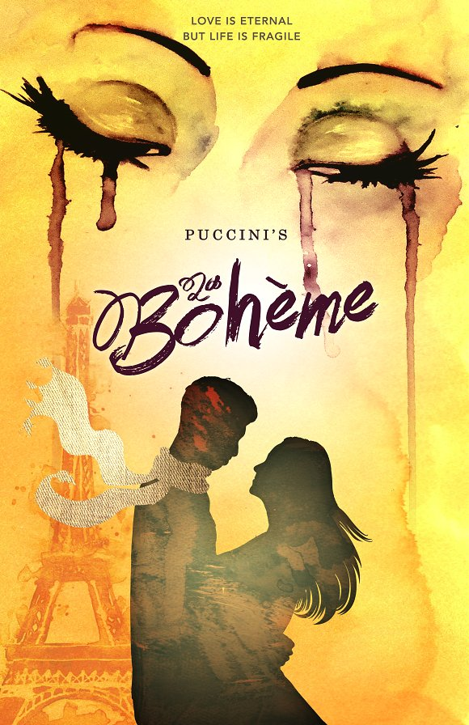
Opera trip Vancouver

"La Bohème"
February 21-22, 2019

This is one of the most famous operas of all time.
Paris in the 19th century. Four young students, best friends, try to survive the cold winter. One of them, Rodolfo, falls madly in love with a young woman called Mimì. But fate has a tragic end for them…

Itinerary:
Bus trip to Vancouver on Thursday Feb 21, 2019
Lunch and shopping at Granville Island
Backstage tour of the Vancouver Opera and meeting the singers
Opera performance in the evening at 7:30 PM
Overnight stay at the Sandman hotel in Vancouver
Breakfast and shopping at MetroTown Mall the next morning and return to Kelowna by Friday afternoon

Cost:
Around $125 dollars, final cost will be finalized by December 2018
To go, you must join Google Classroom code:

